Number Quiz solution - Screenshots

Quiz.pug

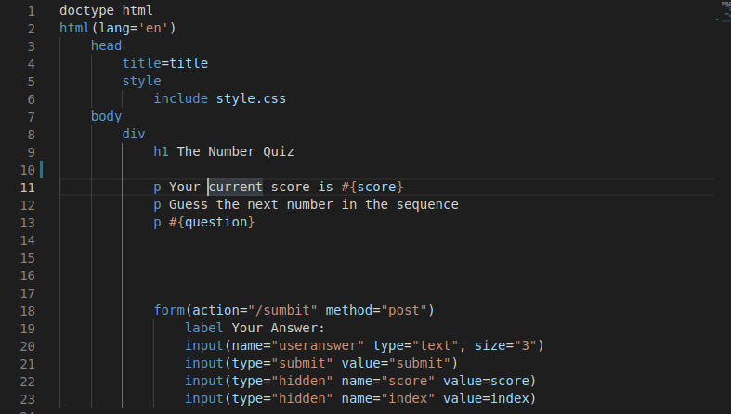

Result.pug

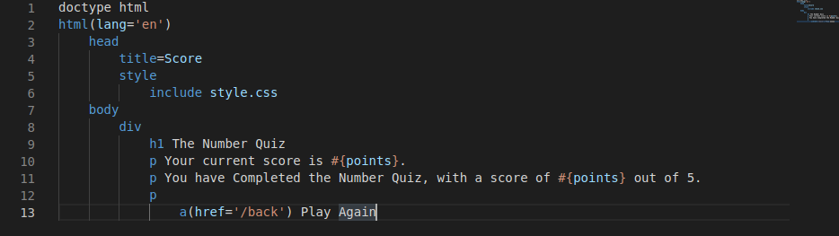

Constants.js

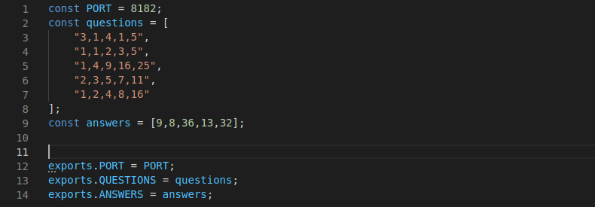

app.js

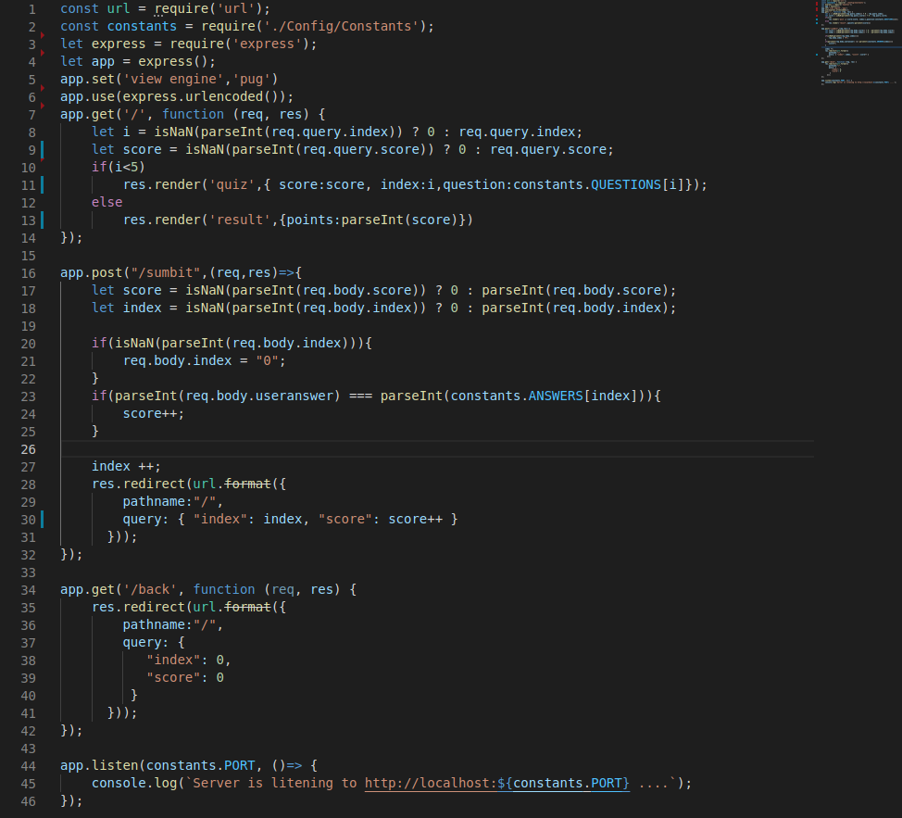

Multiple prayer windows - screenshots

